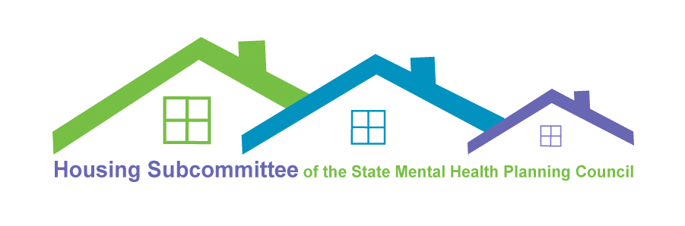
February 10, 2022
Zoom Meeting
9:30am- 11:00am

Minutes

Attendees
- Adrianne Cassidy, Advocates (co-chair)
- Joe Finn, Massachusetts Housing and Shelter Alliance (co-chair)
- Alice Colegrove, Executive Office of Health and Human Services Consultant
- Ali Gold
- Amy Callahan, Edinburg Center
- Andrea Muther, Eliot
- Brent Rourke, Department of Mental Health Northeast Area
- Cecilia Woodworth, Department of Housing and Community Development
- Chris Zabik, Department of Mental Health Western Mass
- Crystal Kozlowski, Open Sky Community Services
- Dev Kaplan, Parent/Professional Advocacy League/YouthMOVE Massachusetts
- Deborah Lovell, Vinfen
- Diana Duquette
- Evan McDonald
- Gary Comeau, Department of Mental Health Central Area
- Heidi Holland, Department of Mental Health Central Office
- Janet Marsden, Metro Boston Homeless Outreach
- Jess Larochelle, Massachusetts Association for Mental Health
- Jill Gichuhi, NAMI Massachusetts
- Joe Vallely, Department of Mental Health Central Office
- Jonathan Bowen-Leopold, Department of Mental Health Central Office
- Keith Wales, Eliot Community Human Services
- Kim Clougherty, Department of Mental Health Central Office
- Mark Bilton, Department of Mental Health Southeast Area
- Rachel Gundersen, BAMSI
- Roxanne Benavides, Open Sky Community Services
- Sabrina Franco, Wayside Youth
- Sally English, Viability
- Steph Doyle
- Stephanie Kan, Department of Housing and Community Development
- Sue Cauley, Viability
- Tom Timms, Department of Housing and Community Development
- Yuka Gordon, Metro Boston Recovery Learning Community

Welcome and Introductions

Co-Chairs Adrianne Cassidy and Joe Finn called the meeting to order. Adrianne welcomed everyone to the meeting. The meeting agenda for this meeting and meeting minutes from the December 9, 2021 meeting were made available to the group in advance.

Review of minutes from 12/9/2021

Adrianne asked for a motion to accept the Minutes from December 9, 2021. Jess Larochelle made a motion to approve, and Gary Comeau seconded. The December minutes were approved by unanimous consent.

DMHRSP Utilization & Housing Updates

Adrianne shared that, in the Metrowest area, major issues include lack of inventory. People are waiting in group living environments and at state facilities for a DMH voucher, and there are few apartment options. Adrianne asked others to share what they are seeing.

Dev Kaplan noted that finding housing is even more challenging for people in the LGBT+ community. He wonders if being creative is a possibility, such as folks renting basements. Stephanie Kan noted while some vouchers do allow shared space like Dev suggested, other voucher programs do not. For these, housing needs to be a standard unit due to funding mechanisms and as a protection measure for voucher holders.

Kim Clougherty asked if DHCD has heard of any creative ideas. Stephanie responses that DHCD is looking at ways to be creative and is open to ideas. Steph Doyle asked if in-law suites would qualify for Section 8 purposes. Stephanie noted that this depends. Local zoning comes into play, the home would have to be zoned as a multi-family home at the local level. Gary Comeau noted that some communities do allow accessory dwellings, and folks in central Mass are looking to build tiny houses. He also encourages people to think creatively.

Alice Colegrove noted that the program she works in has had success with “master leases,” with multiple young adults living in one apartment. Sally English noted that Adult Family Care can also be a good option for people who need support with activities of daily living.

Adrianne stated that they have had some challenges with the DMHRSP, with property owners not wanting to sign a “corporate lease.” They have been successful with tenant-based leases, in some cases, but this is not a good fit for everyone. Linda noted that sometimes these challenges are related to the property owner’s agreements with MassHousing. Adrianne asked members to think about ways to recruit property owners to the DMHRSP program.

Gary said that property changing hands has also added to the challenges. New property owners will often want to raise rents right away.

Dev mentioned that making sure people are in the right setting should be a priority. Some people are being served in higher levels of care who are ready for another setting, but there is not a place for them to go. Steph expressed frustration at policies that are preventing creativity with housing. Working to change these policies is needed.

Sally shared that, in Hampden County, discussions have started regarding changing the definition of who is considered “homeless.” She also noted that the current definition especially impacts people of color, as they are more likely to couch surf.

Joe Finn noted that in MHSA supportive housing programs, they have used their own definition of “homeless” rather than definitions set by federal law. Supportive housing should not have to rely on people being “chronically homeless.” The state of Massachusetts needs a strategic plan for this. DPH’s Bureau of Substance Addiction Services is being especially flexible right now with their programs, which are low-threshold and low-barrier. Joe encouraged members to look at ARPA funding, some of which is aimed at supportive housing, and thinking about creating new inventory.

Joe Vallely provided an update on the DMH Rental Subsidy Program. The funding for the DMHRSP equaled $6 million in 2012, and currently the amount is $16 million. This increase is due, in part, to advocacy from this group. This includes sponsor-based and tenant-based vouchers.

As of December 2021, 1,887 people are benefitting from the DMHRSP. 366 people are in group living environments, and the remainder are in other community-based housing. There are currently 148 individuals on the waitlist for sponsor-based vouchers and 26 for tenant-based.

We do also have a capital funding programs that allows DMH to invest in multi-family housing. There are currently over 1000 units. This two-pronged approach of building and leasing units is needed

2022 Housing Advocacy

Jessica Larochelle provided an update. The Governor has passed the budget. We are fortunate to have the current funding from ARPA and other sources, although growth is not happening in every area. The work this group is doing is working.

The governor’s FY23 proposal includes level funding for the DMHRSP, though there was a $2 million increase last year. EOHHS Secretary Sudders noted in her recent briefing that the upcoming supplemental budget will include a $4 million increase.

Regarding Safe Havens, the Governor’s budget saw increases last year. The New Chardon - Pine Street Inn site got additional support and 3 new sites came online. Funding to sustain all of these is included in this year’s budget. MAMH will give an update in the current weeks. They are thinking about hosting candidate forums or briefings for gubernatorial candidates.

Young Adults & Housing

Heidi Holland noted that there is a lack of young adult representation on the Housing Subcommittee and encouraged members of the Young Adult Council to attend.

Evan, Sabrina, and Steph shared insights into the experiences of young adults, especially long wait times for housing programs and moving into potentially unsafe situations because it seems better than their current situation.

Heidi noted that young people also face “gatekeeping” and people seeing younger people as unready. Setting aside housing options especially for young people is worth looking at. Evan noted that age alone, coupled with lack of rental history, can prevent landlords from renting to young people. Steph opinioned noted that having roommates who are trained to support people daily living skills would be helpful.

Adrianne mentioned the Roommates project and asked how we keep this conversation going.

Peer Supporters & Housing

Jill Gichuhi reminded Subcommittee members that a series of listening sessions were held last year around the state. A list of recommendations was drafted related to supporting people working in peer support roles, as they support people with finding and keeping housing.

Jill noted that the Peer Supporters and Housing project steering committee was recently reformed. The committee met once during the summer and will meet again next month. The committee will prioritize the recommendations and begin planning for addition regional meetings. An additional priority for the project and steering committee is developing a web-based resource for peer supporters related to housing.

Next Meeting Date: Thursday, April 7, 9:30 - 11 am (tentative)

minutes taken by Jill Gichuhi, NAMI Massachusetts

